** San Francisco Bay University**

**EE461L - Verilog HDL Lab**

**Week#2 Verilog Language Concepts**

Name: Melvin Divine Pritchard Student ID: 19857

**Answers :**

1. Run module：

***Reduction Operators***

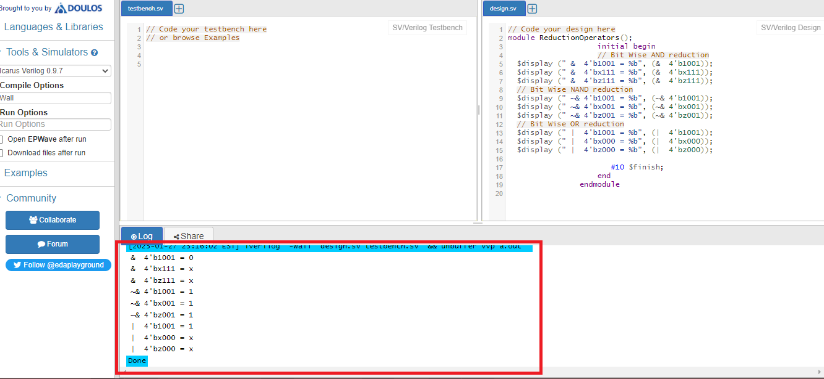

***Shift Operators***

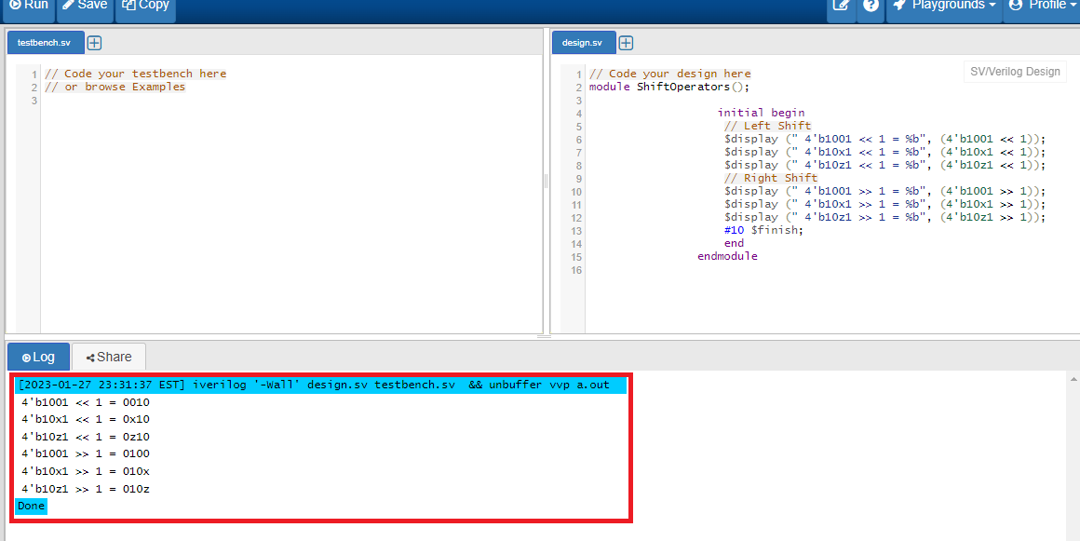

Concatenation Operator

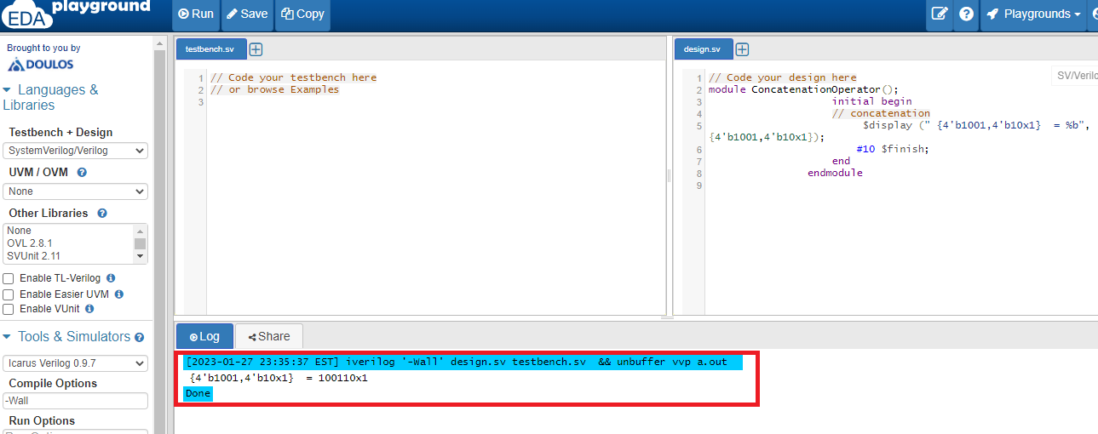

***Replication Operator***

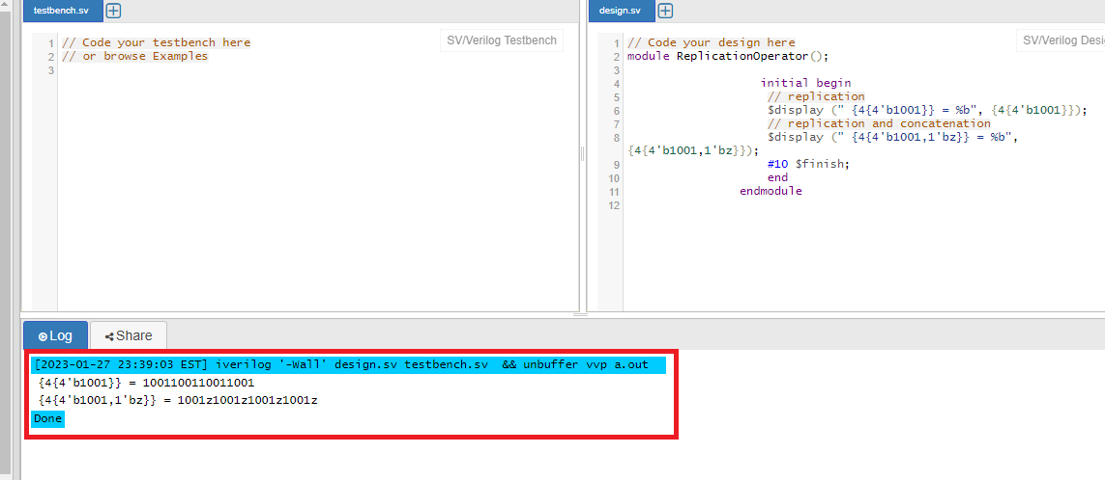

2. Complete the module addbit first, and then run module adder_hier and its testbench.

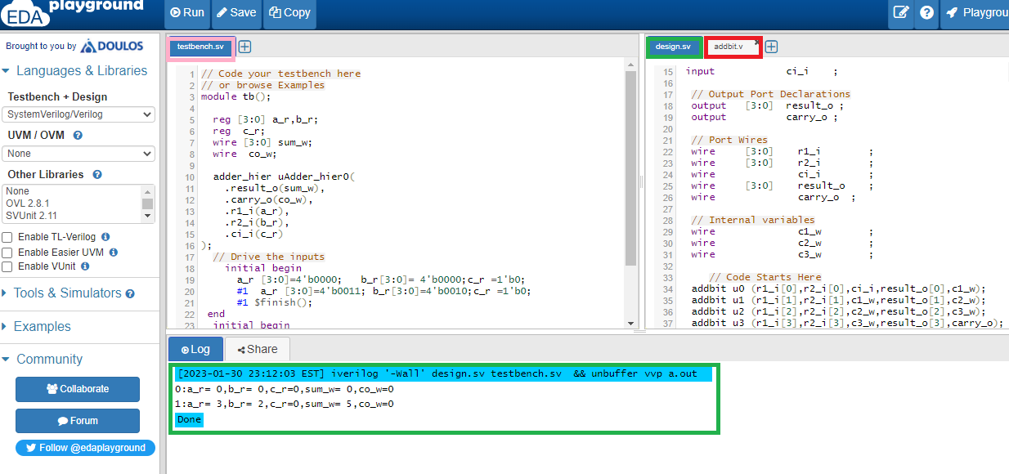

3. Based on the module adder_hier, draw the circuit functional block diagram

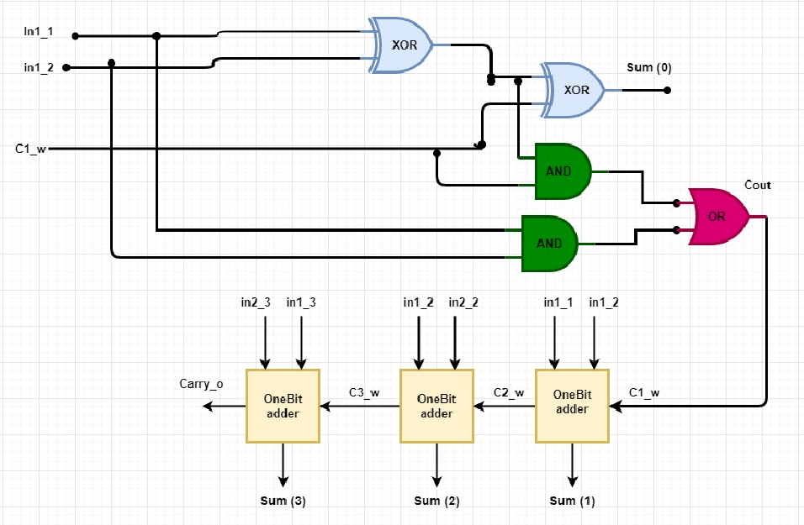

4. Complete the testbenches for the modules DFFSynch, and DFFAsynch in Lab#1

DFFSynch

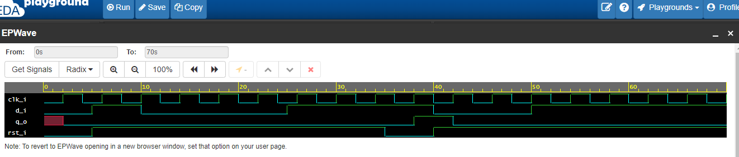

DFFAsynch

